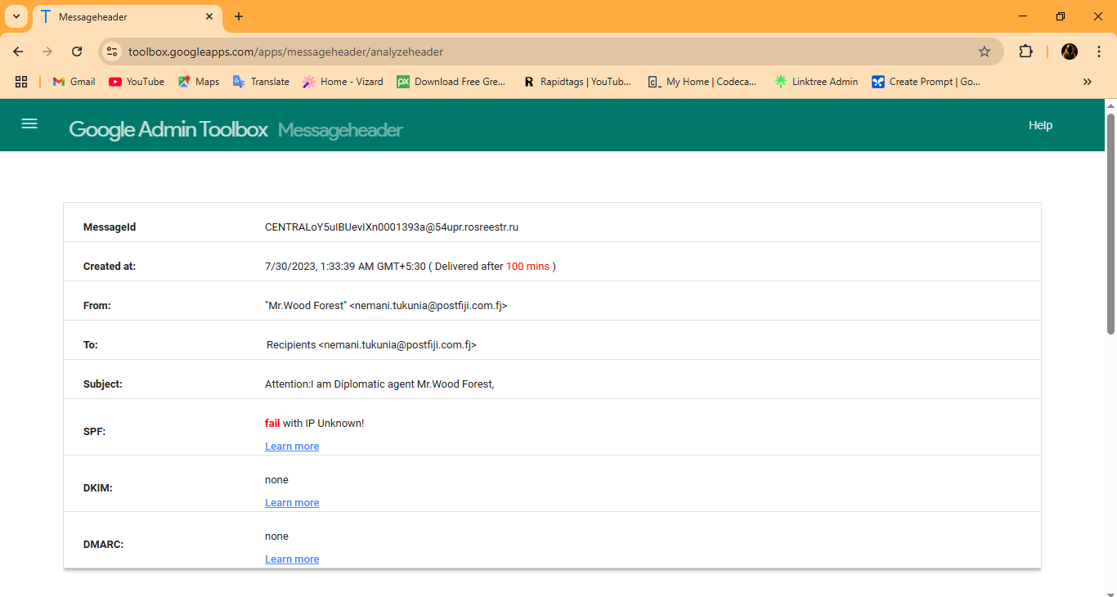

This is the analysis of the email header.

1. SPF - fail.
2. DKIM - none.
3. DMARC - none.

If the above records do not exist, then the domain is easily spoofed.

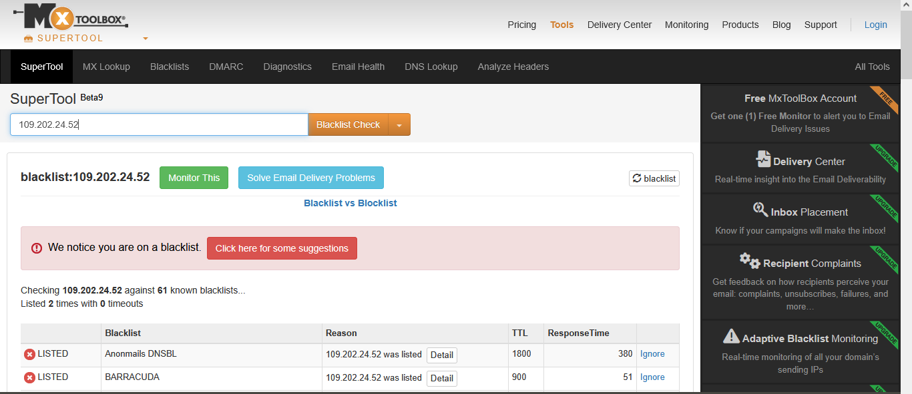

The sender is blacklisted, which is a strong indication that the email is phishing or spoofed.

I tried to find out suspicious links, but I couldn’t find anything. But I found out a lot of spelling and grammatical mistakes with urgent tone.

Here is the sample email in plain text format.

Attention??

I am Diplomatic agent Mr.Wood Forest, I have just arrived here in

your country with your consignment box of funds sum of $10.5million

USD, I'm here at the airport right now and I need you to reconfirm

your home address/current cell phone, so that I can be able to reach

you while coming to your door step right away!

Please hurry up as i do not want to deliver to a wrong destination

area.

Thanks, yours,

Diplomatic agent Mr.Wood Forest

IMF AGENT

Contact Email:mywoodforestbiz.7@gmail.com

1. Punctuation Errors:

* The email starts with "Attention??", which is informal and uses unnecessary question marks. A professional email might use "Subject:" or a formal greeting like "Dear [Recipient's Name],".
* "Mr.Wood Forest" missing space after "Mr.". It should be "Mr. Wood Forest".

1. Grammatical Errors:

* "I am Diplomatic agent" should be "I am a Diplomatic Agent" (add "a" for grammatical correctness and capitalize "Agent" for consistency with the title).
* "while coming to your door step" should be "when coming to your doorstep" ("doorstep" is one word, and "when" is more appropriate than "while").
* "Please hurry up as i do not want to deliver to a wrong destination area" has multiple issues: "i" should be capitalized as "I". "a wrong destination area" is awkward, simplified to "the wrong destination".

1. Professional Issues:

The email lacks a formal greeting and closing. The urgency in "Please hurry up" is unprofessional and characteristic of scam emails, which often pressure recipients to act quickly. The email address "mywoodforestbiz.7@gmail.com" is unprofessional and suspicious, as legitimate diplomatic agents typically use official government or organization email domains.

1. Other Issues:

* Impersonation of IMF.
* Urgent Tone and Request for Personal Information.
* No Specific Recipient Information.

Conclusion:-

* The email from "Mr. Wood Forest" is almost certainly a spoof or scam, exhibiting classic signs of advance fee fraud and phishing, including a suspicious email address, misuse of the IMF’s name, and an urgent request for personal information. The IMF does not engage in such activities, and the lack of verifiable details about "Mr. Wood Forest" or the email address further confirms its phishing nature.